Now, because function modules are created separate to our normal programs, we are given various tools that allow us to test out function modules, without having to write the code to call them.

We are also given the tools to test function modules, completely in isolation. We can test the function module by pressing the F8 key once we're in this screen. Or just click the icon, the little wrench icon.

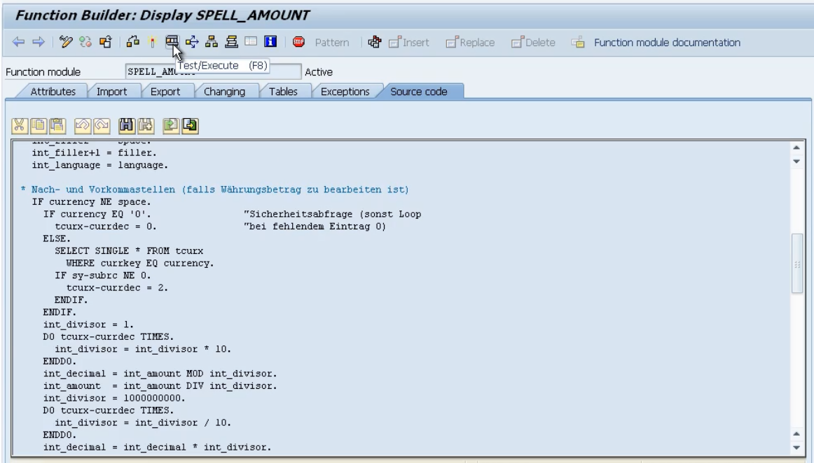

Now I'm going to step back; I'll step back again. Once we're at the first screen of SE37, we can also test it from this location.

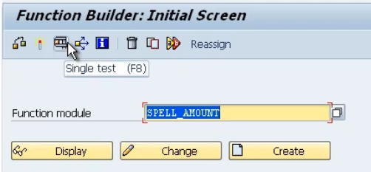

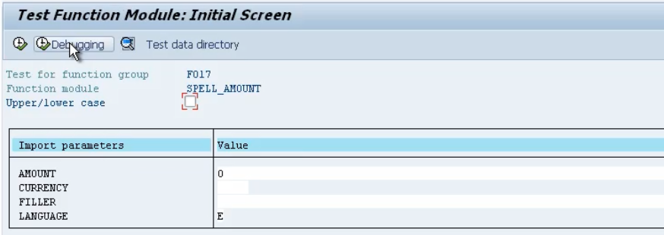

Now every function module that you try, and test will look a little bit different. Because the screen you see is determined from the import parameters, changing parameters, and tables. So, depending on all those settings, your screen will look different, depending on the different function module you want to test.